Year FS
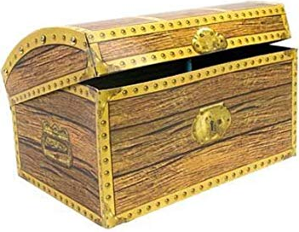
Treasure Chest Books
Book
Elmer By David McKee
We’re Going on a Bear Hunt By Michael Rosen & Helen Oxenbury
Handa’s Surprise By Eileen Browne
Alien’s Love Underpants By Claire Freedman
The Gruffalo By Julia Donaldson & Axel Scheffler
Aaaarrgghh, Spider! By Lydia Monks
Shark in the Park! By Nick Sharratt
Puffin Peter By Petr Horacek
Rainbow Fish By Marcus Pfister
Room on the Broom By Julia Donaldson
The Jolly Postman By Allan Ahlberg & Janet Ahlberg
Dear Zoo By Rod Campbell
How to Catch a Star By Oliver Jeffers
Harry and the Bucketful of Dinosaurs By Ian Whybrow & Adrian Reynolds
Supertato By Sue Hendra & Paul Linnet
Out and About: A First Book of Poems By Shirley Hughes
Hooray for Fish! By Lucy Cousins
Mog the Forgetful Cat By Judith Kerr
Bears Don’t eat Egg Sandwiches By Julia Fulton & Rachel Suzanne
You Can’t Take an Elephant on the Bus By Patricia Cleveland & David Tazzyman
Night Time: Peek Inside By Anna Milbourne & Simona Dimitri
Whatever Next By Jill Murphy
Brown Bear, Brown Bear By Eric Carle
Guess How Much I Love You By Sam McBratney & Anita Jeram
The Very Hungry Caterpillar By Eric Carle
Commotion in the Ocean By Giles Andreae & David Wojtowycz
Harry & the Robots By Ian Whybrow & Adrian Reynolds
Fairy Tales for Little Children By Various
Mr Wolfs Pancakes By Jan Fearnley
How Many Legs By Kes Gray & Jim Field

