21st December 2018

Dear Parents and Carers,
As you will be aware, Inspectors from the Diocesan Inspection Service carried out a one day inspection at St Patrick’s on 5 December 2018. All Catholic Schools are inspected every 5 years. These inspections focus on the Catholic Life of the school, the quality of Religious Education and the quality of Collective Worship. In 2013 St Patrick’s was judged as ‘outstanding’.
Since then, the Diocesan Education Service, working with other Dioceses across the country, has rewritten the inspection framework to make it more rigorous. This is to reflect the high standards of Catholic education we expect from all of our schools. Previously, a school needed to be ‘outstanding’ in two of the three areas to be judged ‘outstanding’ overall. Under the new framework, schools must be judged ‘outstanding’ in all three areas. It is expected that ‘outstanding’ will occur less frequently and become an exceptional performance.
As you will know, St Patrick’s is a wonderful, warm community, where the children have opportunities every day to encounter Jesus through a rich range of activities. I am pleased to announce that the school was graded ‘outstanding’ in the areas of Catholic Life and Collective Worship. This is a wonderful achievement and the inspectors highlighted the school’s many strengths:
“Pupils live out the school’s mission by ‘belonging, caring, sharing - safe in the arms of God’s love’.”
“…the development of pupil spirituality is a high priority for leaders who are fully committed to their work. “
“Pupils engage in worship opportunities, relishing the chance to plan and lead liturgy, welcoming times to pray and reflect.”
Religious Education was also seen as a strength, with some areas for further refinement and was graded ‘good’. As a result, the school’s overall judgment is ‘good’. Within the context of the new, more challenging framework, achieving two ‘outstanding’ judgments and one ‘good’ is a highly commendable performance.
I continue to be impressed by the exceptional care and love shown to the children at St Patrick’s and by the way the children live out their faith and show such enthusiasm for all aspects of school life. Mrs Smedley and all of the staff, governors and children within the school can be really pleased with this inspection report. I would encourage you to read the report, which is attached to this letter, as it underlines why St Patrick’s is such a wonderful Catholic school.
Yours faithfully
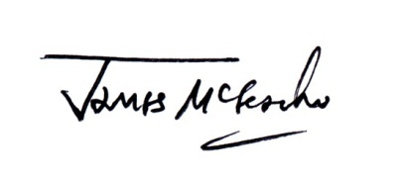
James McGeachie
CEO, Our Lady of Lourdes Catholic Multi Academy Trust

