Year 1
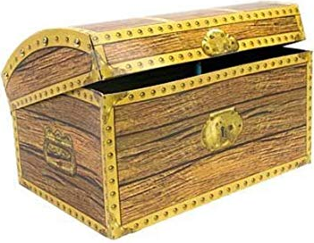
Treasure Chest Books
Book
Where the Wild Things Are By Maurice Sendak
Meerkat Mail By Emily Gravett
Not Now Bernard By David McKee
Dogger By Shirley Hughes
The Stick Man By Julia Donaldson & Axel Scheffler
A First Book of Nature By Nicola Davies & Mark Hearld
The Tiger Who Came to Tea By Judith Kerr
Cat In The Hat By Dr. Seuss
Fairytale News By Colin Hawkins & Jacqui Hawkins
Hairy Maclary from Donaldson’s Dairy By Lynley Dodd
We’re going on a Bear Hunt By Michael Rosen & Helen Oxenbury
Monstersaurus By Claire Freedman & Ben Cort
Owl Babies By Martin Waddell & Patrick Benson
The Snail and The Whale By Julia Donaldson & Axel Scheffler
The Tiny Seed By Eric Carle
Tree: Seasons Come, Seasons Go By Patricia Hegarty & Britta Teckentup
The Day the Crayons Quit By drew Daywalt & Oliver Jeffers
The Enormous Crocodile By Roald Dahl
The Mousehole Cat By Antonia Barber & Nicola Bayley
Click, Clack, Moo: Cows That Type By Doreen Cronin
Farmer Duck By Martin Waddell & Helen Oxenbury
Kipper By Mick Inkpen
Look What I’ve Got By Anthony Browne
Whatever Next By Jill Murphy
The Rabbit belongs to Emily Brown By Cressida Cowell & Neal Layton
Goodnight Everyone By Chris Haughton
I can only draw worms By Will Mabbitt
Funny Bones By Allan Ahlberg & Janet Ahlberg
Cops & Robbers By Allan Ahlberg
The Dark By Lemony Snicket & Jon Klassen
Ricky Rocket Weekend in Orbit By Shoo Rayner

