Year 2
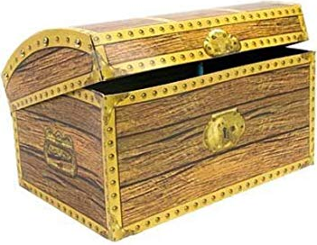
Treasure Chest Books

Book
The Giraffe and The Pelly and Me By Roald Dahl
Traction Man By Mini Grey
The Owl Who was Afraid of the Dark By Jill Tomlinson
The Hodgeheg By Dick King-Smith
The Great Pape Caper By Oliver Jeffers
Man on the Moon By Simon Bartram
Paddington By Michael Bond
Amazing Grace By Mary Hoffman
The Magic Finger By Roald Dahl
The Lighthouse Keeper’s Lunch By Ronda Armitage
The Penguin Who Wanted to Find Out By Jill Tomlinson
The Day the Crayons Came Home By Drew Daywalt & Oliver Jeffers
Flat Stanley By Jeff Brown
Beegu By Alexis Deacon
Into the Forest By Anthony Browne
A Planet Full of Plastic By Neal Layton
The Princess and The Pea By Mini Grey
Oi Dog! By Kes Gray
Grandad’s Island By Benji Davies
The Night Pirates By Peter Harris
Salty Dogs By Matty Long
Dougall’s Deep Sea Diary By Simon Bartram
Hotel Flamingo By Alex Milway
The Queen’s Nose By Dick King-Smith
Rainbow Bear By Michael Morpurgo
The Legend of Spud Murphy By Eoin Colfer
Mr Majeika By Humphrey Carpenter
Mrs Wobble the Waitress By Allan Ahlberg
Don’t Look in this Book By Samuel Langley-Swain
Dr Xargle’s Book of Earthlets By Jeanne Willis
Princess DisGrace Third Term at Tall Towers By Lou Kuenzler
Spy Pups By Andrew Cope
Amelia Jane Gets Into Trouble By Enid Blyton

