Year 4
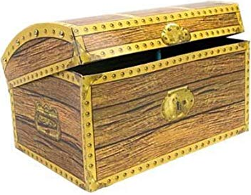
Treasure Chest Books
Book
Anne of Green Gables By Lucy M. Montgomery
James and the Giant Peach By Roald Dahl
The Lion, the Witch and the Wardrobe By C.S. Lewis
The Butterfly Lion By Michael Morpurgo
The Fib and Other Stories By George Layton
The Accidental Prime Minister By Tom McLaughlin
The Firework Maker’s Daughter By Philip Pullman
The Wind in the Willows By Kenneth Grahame
How to Train Your Dragon By Cressida Cowell
Charlotte’s Web By E.B. White
Oliver Twist (Abridged) By Charles Dickens
I Don’t Like Poetry By Joshua Seigal
Please Mrs Butler By Allan Ahlberg
The Apprentice Witch By James Nicol
Run Wild By Gill Lewis
Charlie and the Chocolate Factory By Roald Dahl
Mr Popper’s Penguins By Richard Atwater
The Water Horse By Dick King-Smith
The Wolf’s Footprints By Susan Price
The Accidental Secret Agent By Tom McLaughlin
The Accidental Billionaire By Tom McLaughlin
The Accidental Father Christmas By Tom McLaughlin
The Accidental President By Tom McLaughlin
The Accidental Rock Star By Tom McLaughlin
Nelly the Monster Sitter By Kes Gray
The War Next Door By Phil Earle
Demolition Dad By Phil Earle
Superhero Street By Phil Earle
Oliver and the Seawigs By Philip Reeve
Jinks and O’Hare Funfair Repair By Philip Reeve
Pugs of the Frozen North By Philip Reeve
Cakes in Space By Philip Reeve
The Dread Pirate Fleur & The Ruby By Sara Starbuck
Tom Truehart and the Land of Dark Stories By Ian Beck
Judy Moody goes to College By Megan McDonald
The Box of Delights By John Masefield

