Year 5
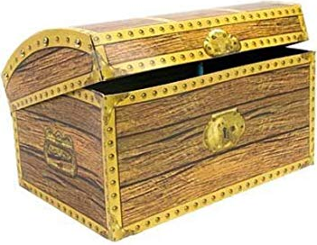
Treasure Chest Books

Book
The Witches By Roald Dahl
The Goldfish Boy By Lisa Thompson
Harry Potter and the Philosopher’s Stone By J.K. Rowling
Clockwork By Philip Pullman
Room 13 By Robert Swindells
There’s a Boy in the Girls’ Bathroom By Jillian Powell
The Explorer By Katherine Rundell
Beetle Boy By M.G.Leonard
The Boy at the Back of the Class By Onjali Rauf
Happy Poems By Roger McGough
The Storm Keeper’s Island By Catherine Doyle
The Secret Garden By Frances Hodgson Burnett
Five Have Plenty of Fun By Enid Blyton
Hetty Feather Series By Jacqueline Wilson
Skellig By David Almond
Time Travelling With a Hamster By Ross Welford
Stormbreaker By Anthony Horowitz
A Monster Calls By Patrick Ness
Beowulf By Michael Morpurgo
The Rainmaker Danced By John Agard & Satoshi Kitamura
The Silver Sword By Ian Serraillier
Silly Verse for Kids By Spike Milligan
Roller Girl By Victoria Jamieson
The Scarecrow and his Servant By Philip Pulman
Birthday Boy By David Baddiel
The Mystery of Wickworth Manor By Elen Caldecott
The Parent Agency By David Baddiel
Operation Eiffel Tower By Elen Caldecott
Alice in Wonderland By Lewis Carroll
Little Women By Louisa May Alott
The Bell Family By Noel Streatfeild
Best Mates By
Best Friends By Jacqueline Wilson
Five Children and It By E Nesbit
Cautionary Tales By Hilaire Belloc
Rose and the Silver Ghost By Holly Webb
Man of the Match By Dan Freedman
Jane Blonde Spylets are Forever By Jill Marshall
Not Bad for a Bad Lad By Michael Morpurgo
The Wreck of the Zanzibar By Michael Morpurgo
Romeo & Juliet By William Shakespeare
Mr Nobody’s Eyes By Michael Morpurgo
The Silver Sword By Ian Serraillier
The Elephant Thief By Jane Kerr

