Year 6
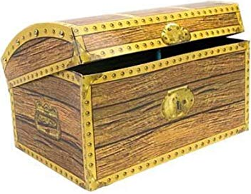
Treasure Chest Books

Book
Tom’s Midnight Garden By Philippa Pearce
Holes By Louis Sachar
I was a Rat By Philip Pulman
Head Kid By David Baddiel
Kensuke’s Kingdom By Michael Morpurgo
Alone on a Wide, Wide Sea By Michael Morpurgo
The Boy in the Striped Pyjamas By John Boyne
Journey to Jo’burg By Beverley Naidoo
Boy By Roald Dahl
Goodnight Mr Tom By Michelle Magorian
Wonder By R.J. Palacio
Pig Heart Boy By Malorie Blackman
The Boy Who Flew By Fleur Hitchcock
A Christmas Carol By Charles Dickens
Aesop’s Fables By Aesop
Artemis Fowl By Eoin Colfer
Northern Lights By Philip Pullman
War Horse By Michael Morpurgo
Carrie’s War By Nina Bawden
My Brother is a Superhero By David Solomons
Love That Dog by Sharon Creech
Oranges in No Man’s Land By Elizabeth Laird
Cogheart By Peter Bunzl
Lost Magic By Brian Moses
Moon Juice By Kate Wakeling
The Extraordinary Colours of Auden Dare By Zillah Bethell
Ani Malcolm By David Baddiel
The Person Controller By David Baddiel
The Great Ice-Cream Heist By Elen Caldecott
How Ali Ferguson Saved Houdini By Elen Caldecott
Black Beauty By Anna Sewell
The Saga of Darren Shan Trials of Death By Darren Shan
The Adventures of Tom Sawyer By Mark Twain
The Boy Who Went Magic By A.P. Winter
Framed By Frank Cottrell Boyce
How to Fly with Broken Wings By Jane Elson
Listen to the Moon By Michael Morpurgo
Treasure Island By Robert Lewis Stevenson
The Children of Castle Rock By Natasha Farrant

