History Knowledge Organiser – Anglo-Saxons
What I should already know
- In the past, people didn’t have the same technology we have nowadays
- The earliest people that lived in Britain made weapons from stones, bronze and iron
- Archaeologists found out about the past by looking at artefacts
- Romans invaded and settled in Britain bringing towns, roads and construction
Time line
What knowledge and skills I will gain during this topic
Develop a chronologically secure knowledge and understanding of British and world history
Develop the appropriate use of historical terms
Understand how our knowledge of the past is constructed from a range of sources
Construct informed responses that involve thoughtful selection and organisation of relevant historical information
Note connections, contrasts and trends over time
Regularly address and devise historically valid questions about significance.
Key Vocabulary
Angles | People from Germany who invaded Britain around 410 A.D.
Anglo-Saxon | The name given to people who travelled from Germany and South Denmark and settled in Britain
Invasion | To enter as an enemy, by force, in order to conquer or plunder.
Jutes | People from the Jutland peninsula (Germany and South Denmark)
Dark Ages | Referring to the period of time after the fall of the Roman Empire (first half of the Middle Ages). 500AD – 1000AD
pagan | A person observing a religion based on the worship of nature or the earth.
hoard | A supply usually of something of value stored away or hidden.
trench | A long narrow ditch.
archaeologist | A person who studies things that people made, used and left behind.
preserved | To keep or save.
decay | To break down slowly by natural processes.

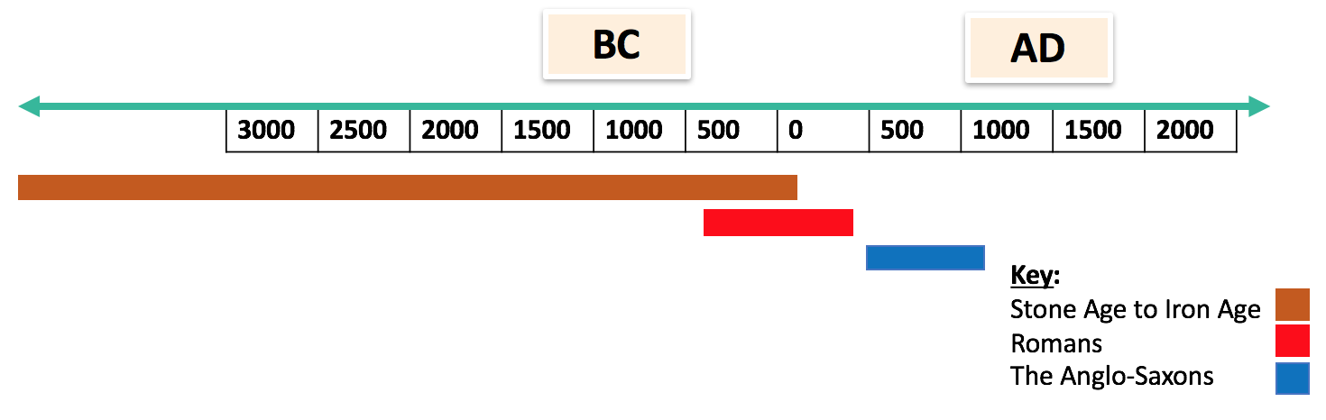
Maps and images
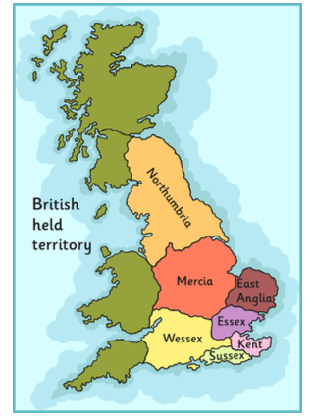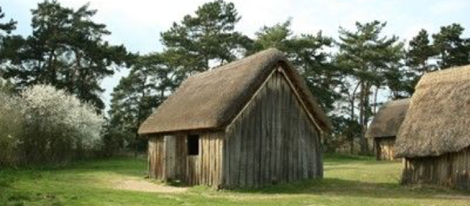
Knowledge
Where did the Anglo-Saxons come from? The Romans left Britain in 410 due to fierce tribes attacking Italy and every soldier was needed back at home to defend the country. Without an army of its own, it left the country vulnerable to attackers. The Anglo-Saxons came from Denmark, Netherlands and northern Germany across the North Sea in wooden boats. They conquered England but failed to conquer Scotland, Wales and Cornwall (an area of south-west England).

Who were the Anglo-Saxons?
The Saxons were not just one set of people – they included Jutes, Danes, Friesians –
but for convenience, historians talk about them as Saxons. After the Romans
left, some Saxons were invited to come to eastern England to help protect the country from invasion. As Britain was relatively rich, many more came – making up perhaps one-quarter of the population. In some places, Saxons and Britons co-existed quite happily, but not everywhere. It took a long time for things to settle down; even then, strong kings would expand the areas they controlled, whereas weak kings would lose land. Despite this, England was still a rich country.
Saxons were initially pagans, but gradually they became Christian, building churches and setting up monasteries, which became centres of learning. There is plenty of evidence of trade with the rest of the world. As ever, Saxon society contained both very rich and powerful people, and many who were poor or slaves.

