Science Knowledge Organiser – Earth and Space
What I should already know/ be aware of
- The sun and familiar with some of the planets.

- The Sun’s apparent movement across the sky from light and shadows topic.
What knowledge and skills I will gain during this topic
Describe the movement of the Earth and other planets relative to the Sun in the Solar System.
Describe the movement of the Moon relative to the Earth.
Use the idea of the Earth’s rotation to explain day and night and the apparent movement of the Sun across the sky.
Key Vocabulary
daytime | The time when part of the Earth is in daylight
geocentric | The earth is at the centre of the Solar System (Earth centred)
heliocentric | The Sun is at the centre of the Solar System. (Sun centred)
night-time | The time when part of the Earth is in darkness
orbit | The path of a planet or moon around another celestial object
solar system | A series of planets that orbit a star
star | An astronomical body that produces its own energy
Sun | The star at the centre of our Solar System
time zone | A geographical region where the same time is set

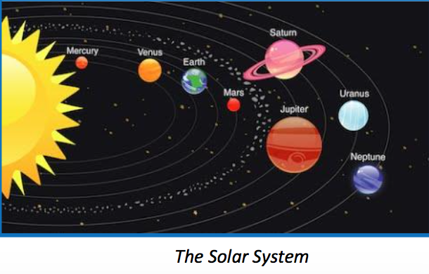
Knowledge
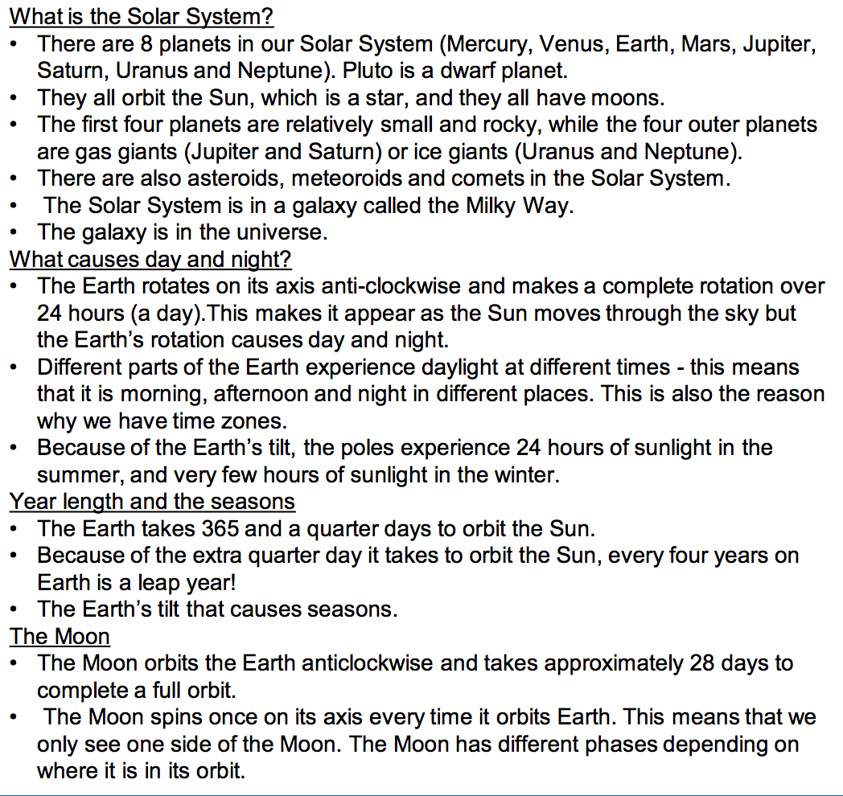
Heliocentric model
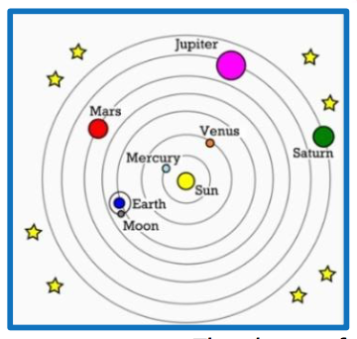

Geocentric model
