Science Knowledge Organiser – Let’s get moving!
What I should already know/ be aware of
- Types of forces such as friction.
- What a force is
and that some forces do not have to be in contact
to act.
What knowledge and skills I will gain during this topic
Explain that unsupported objects fall towards the Earth because of the force of gravity acting between the Earth and the falling object.

Identify the effects of air resistance, water resistance and friction, that act between moving surfaces.

Recognise that some mechanisms, including levers, pulleys and gears, allow a smaller force to have a greater effect.
Key Vocabulary
Air resistance | The resistance of air to forward movement
Force meter | An instrument for measuring forces
Friction | The force made when two objects rub against each other
Gravity | The force that attracts a body towards the centre of the Earth
Newton | The unit of force
Non-contact force | A force that does not need to  touch an object to work, e.g. magnetic force
Reliable | Something that can be depended on
Water resistance | The resistance of water to  forward movement
Weight | The force with which something is attracted  to the Earth

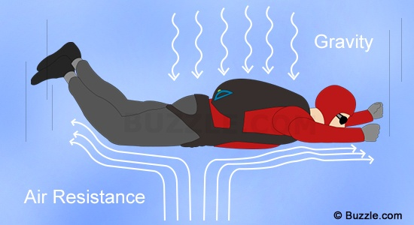
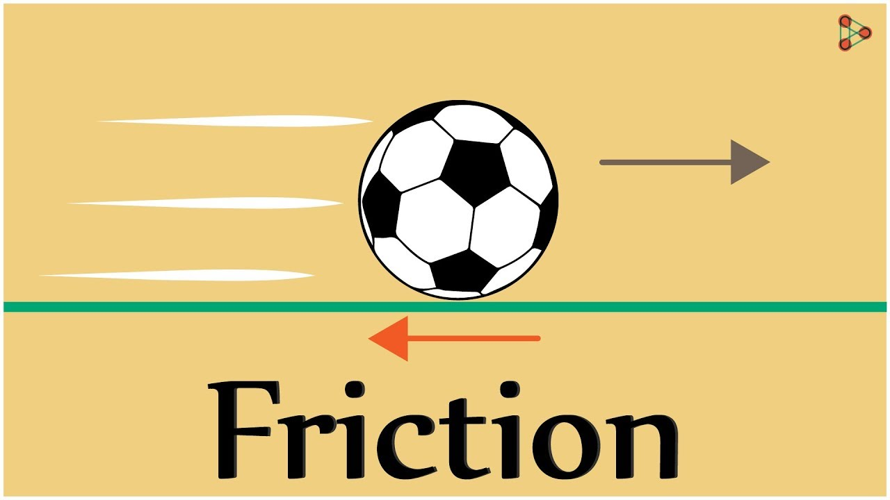

Knowledge
Gravity
Gravity is an attractive, non-contact force. It is measured in Newtons (N). Any two objects have a force of gravity between them. This only becomes obvious when the objects have a very large mass, such as the Earth, Moon or Sun. Gravity gives weight to objects with mass and causes them to fall towards the centre of the Earth when dropped.

Galileo and Newton
Galileo discovered that everything falls at the same speed. In 1658 he dropped two balls of different masses from the leaning tower of Pisa. He discovered they hit the ground at the same time.
Sir Isaac Newton first set out the laws of gravity. A force of attraction pulls together all matter (anything you can physically touch). The more matter something has, the greater the force of its gravity. That means really big objects like planets and stars have a stronger gravitational pull.
Albert Einstein further developed the theory of gravity. He didn’t believe it was a force at all. Instead, he said gravity was a distortion in the shape of space–time, otherwise known as ‘the fourth dimension’.

Friction
Friction is a force. It occurs when any two things rub against each other. These can be solid things, like your two hands rubbing together or a hammer hitting a nail.
They can be gases, like the air slowing down your car. In this case, we call the friction air resistance. And finally, friction can occur in liquids, such as when water slows down a boat. The size of the friction force can be very big; two rough surfaces will generate more friction than two smooth surfaces. Air and water resistance are what’s known as drag forces. These depend on the shape, size and speed of the object that is moving through the air or water. Streamlining jet planes or submarines reduces the air or water resistance, allowing the objects to move through air or water much better.

