Science Knowledge Organiser | Growing Up and Growing Old | Year 5

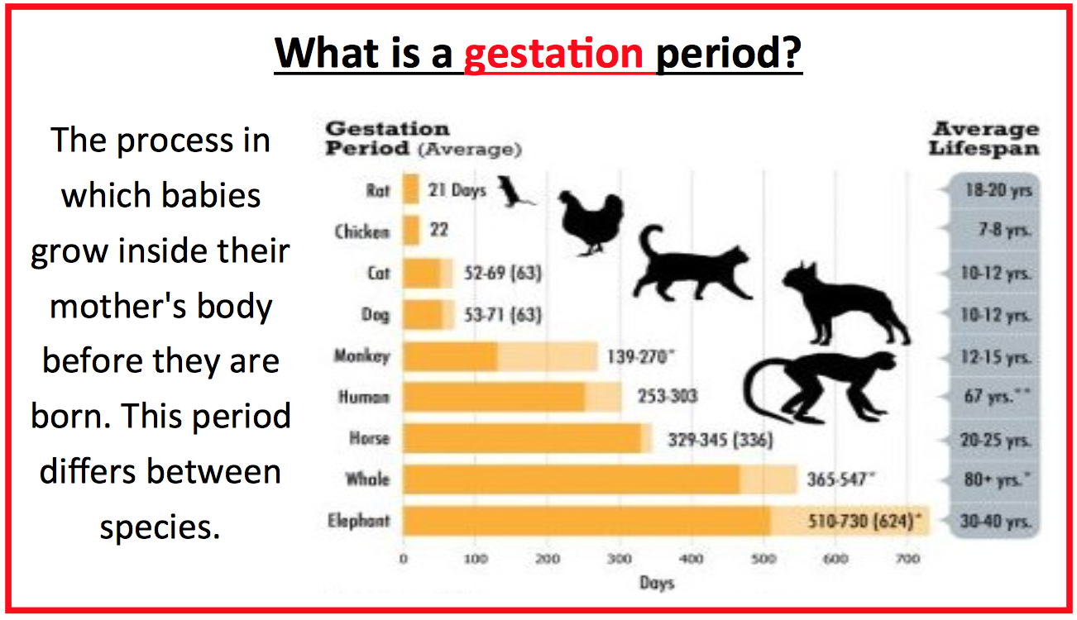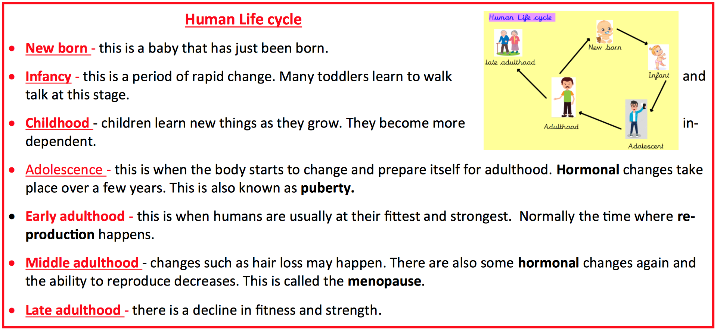
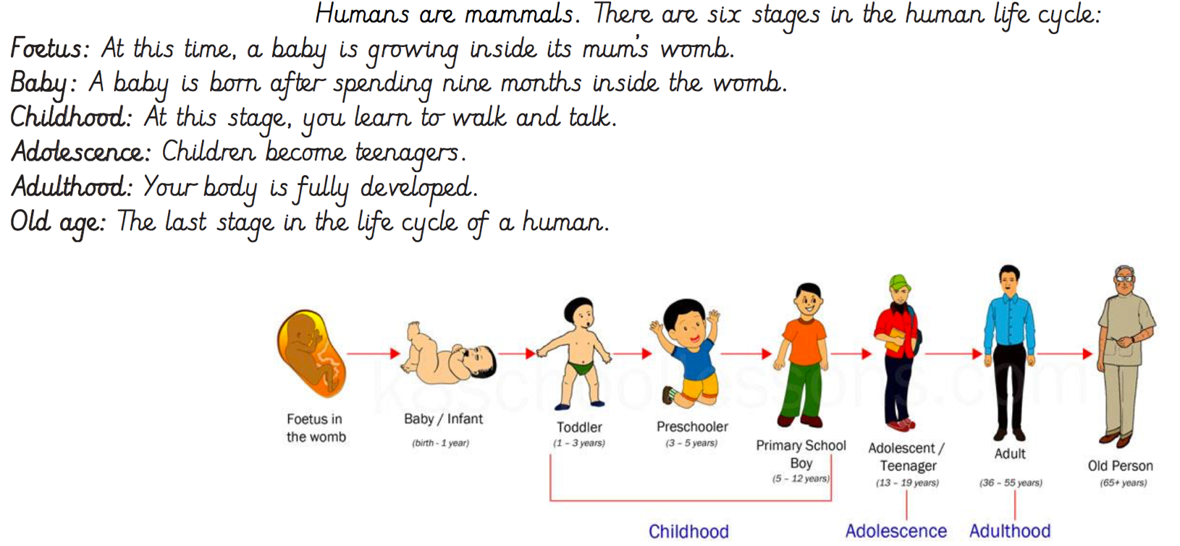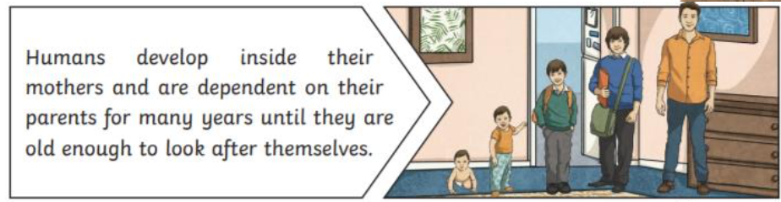

Working Scientifically
Plan different types of enquiry to answer questions | Take measurements with increasing accuracy | Record results using diagrams and tables | Use test results to make further predictions | Report and present findings

