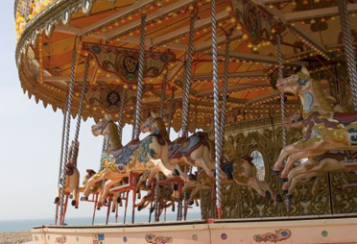

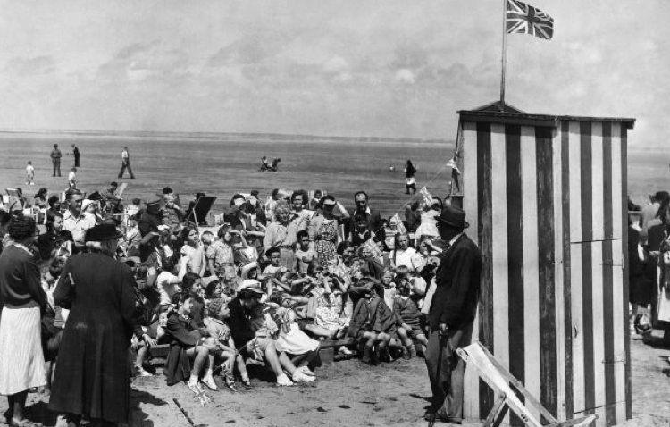

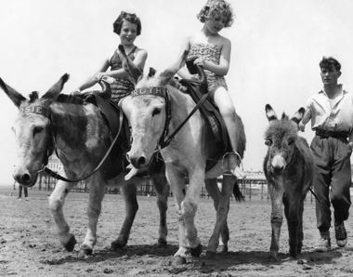

|  |
| --- |
| Key knowledge |
| Postcards were a popular way to communicate with family and friends. |
| The box brownie camera was invented in 1900 as a cheap way to photograph and keep memories. |

|  |  |
| --- | --- |
| Vocabulary | |
| Seaside resort | A town, village or hotel located on the coast. |
| Souvenir | A thing that is kept as a reminder of a person, place or event. |
| Pier | A platform going from the shore into the sea. |
|  |  |
|  |  |
|  |  |
|  |  |

Timeline of the recent past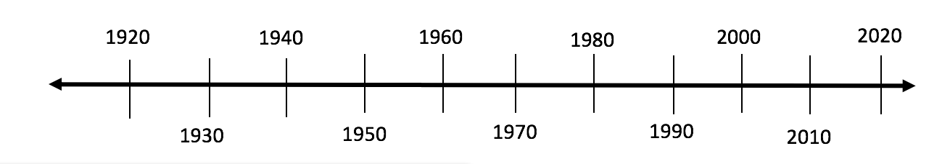

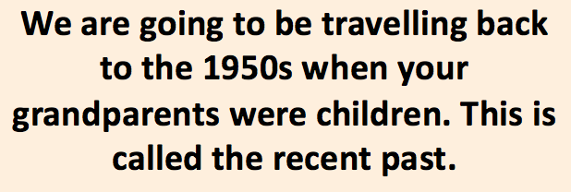

After the war more people had jobs, were paid more and given time off for holidays. This extra money was used to pay for family holidays.

Book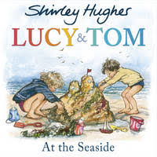

Holidays

How have holidays changed over time?