Topic Knowledge Organiser – Journeys: Trade
What I should already know/ be aware of
- Children may have looked at the geography of food in KS 1
- Children should have an understanding of different trades and how things are made.

What knowledge and skills I will gain during this topic
In this unit, the children will find out about the UK’s global trade links, investigating where everyday products come from and the journeys they take to our homes. The children will also map the journeys taken by items and research the pros and cons of buying local or imported goods.
Key Vocabulary
Biomes | A biome is way to describe a large group of similar ecosystems. Biomes have similar weather, rainfall, animals, and plants. There are a number of biomes on planet Earth.
Continent | A continent is one of the larger continuous masses of land; Asia, Africa, North America, South America, Antarctica, Europe, and Australia
Region | An area, especially part of a country or the world that has set characteristics but not always fixed boundaries.
Imported | Goods that are brought into a country from abroad for sale.
Trade | The action of buying and selling goods and services.

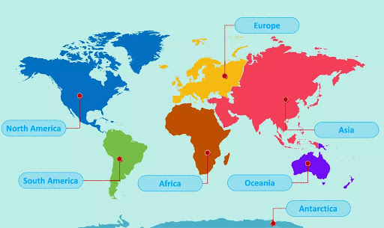

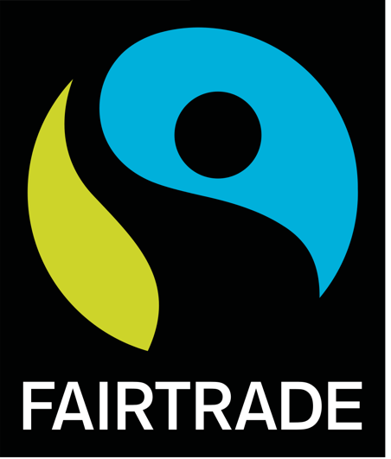

Knowledge
Fair Trade
There are many steps involved in selling goods. Bananas, for example, are generally grown on plantations. This means the plantation owner has to make sure that the ground is taken care of and fertilized. They also have to pay for fruit pickers to harvest the fruit and for machinery for the plantation. Exporters then transport the bananas by ship and pay for their own fuel, any lost or damaged stock and port fees. Importers then transport the bananas from the port to ripening centres and pay for workers and transportation to move them. The ripening centres have to pay for their operating costs, gases used for ripening and staff. Finally, the retailer sells the bananas but also pays for staff to work in shops, advertising and the costs of any stock that goes off or isn’t sold. There are lots of steps in the trade process, but people involved are not always paid equally or fairly. Fair trade exists to make sure that people are not exploited. Look out for the fair-trade logo when buying things so that you know that people have been paid fairly for their work

How trade has changed
Trade has changed a lot through history. This is partly due to developments in transportation but also due to the changing relationships of the UK with other countries. In Tudor times, the UK traded with the Americas, whereas in Victorian times, the UK mainly traded with other countries who were in the British Empire

