made by Sophie Bartlett @_MissieBee

YEAR 6 MATHS KNOWLEDGE ORGANISER

**Co-ordinates**Read co-ordinates along the x axis (horizontal) first, then the y axis (vertical). E.g. (3,-4) = go right 3, down 4.

**Roman numerals**

|  |  |  |  |
| --- | --- | --- | --- |
| 1 | I | 100 | C |
| 5 | V | 500 | D |
| 10 | X | 1000 | M |
| 50 | L |  |  |

**2D shapes**

|  |  |
| --- | --- |
| **Name** | **No. of sides** |
| quadrilateral | 4 |
| pentagon | 5 |
| hexagon | 6 |
| heptagon | 7 |
| octagon | 8 |
| nonagon | 9 |
| decagon | 10 |

polygon = shape with straight sides  
regular = all sides/angles the same  
irregular = sides/angles **not** same

**Types of triangle  
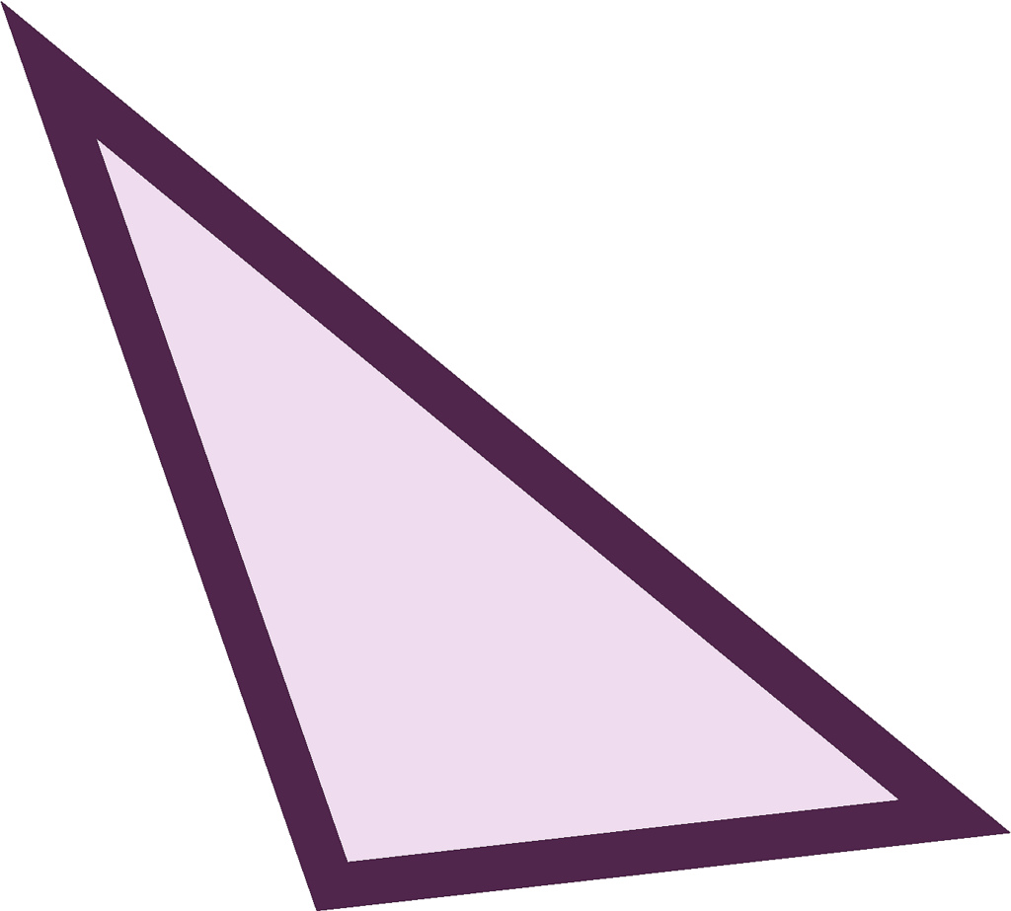 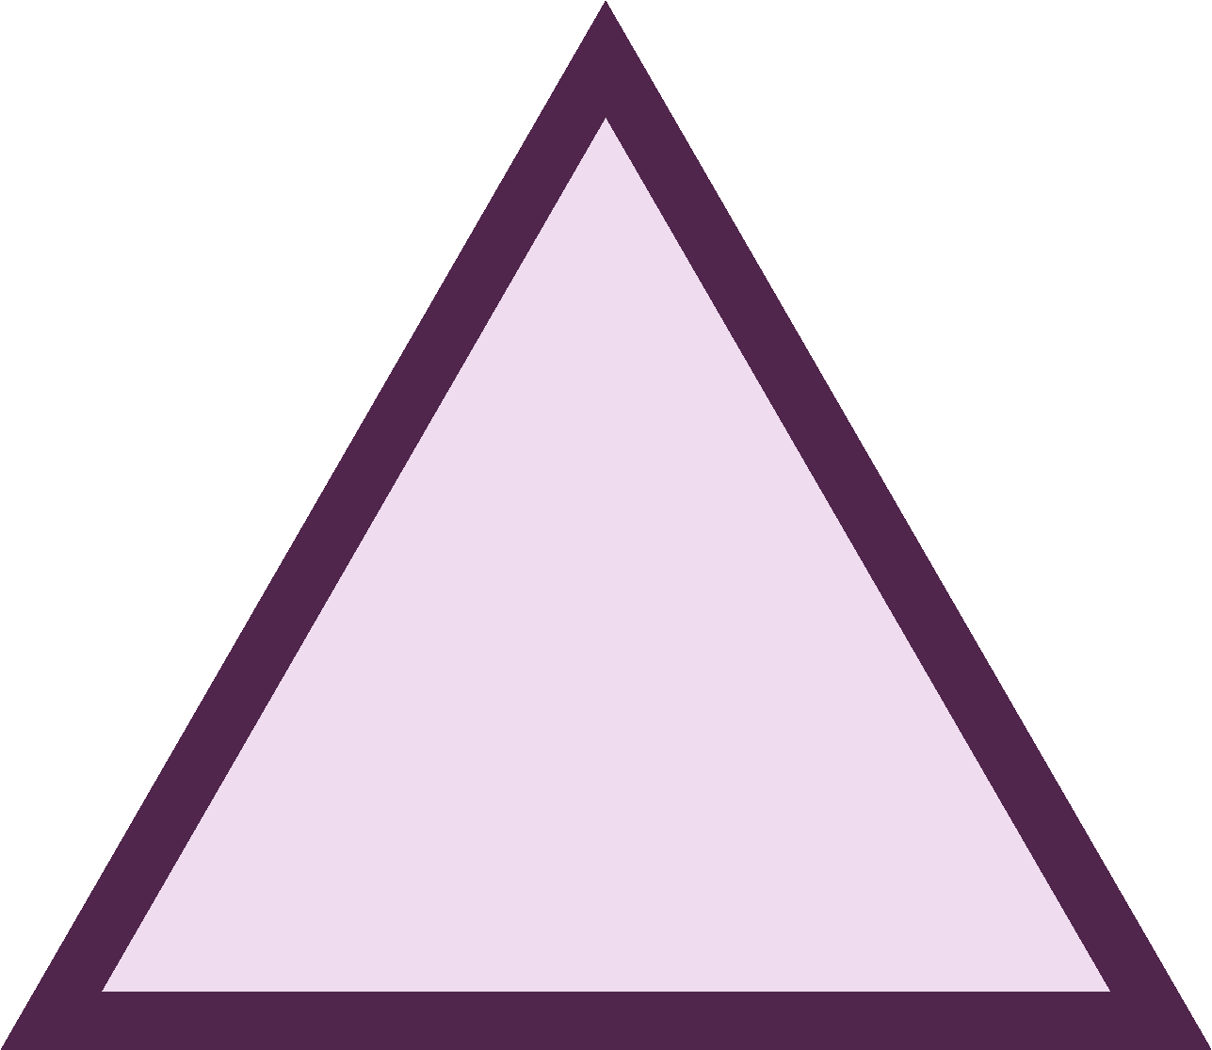 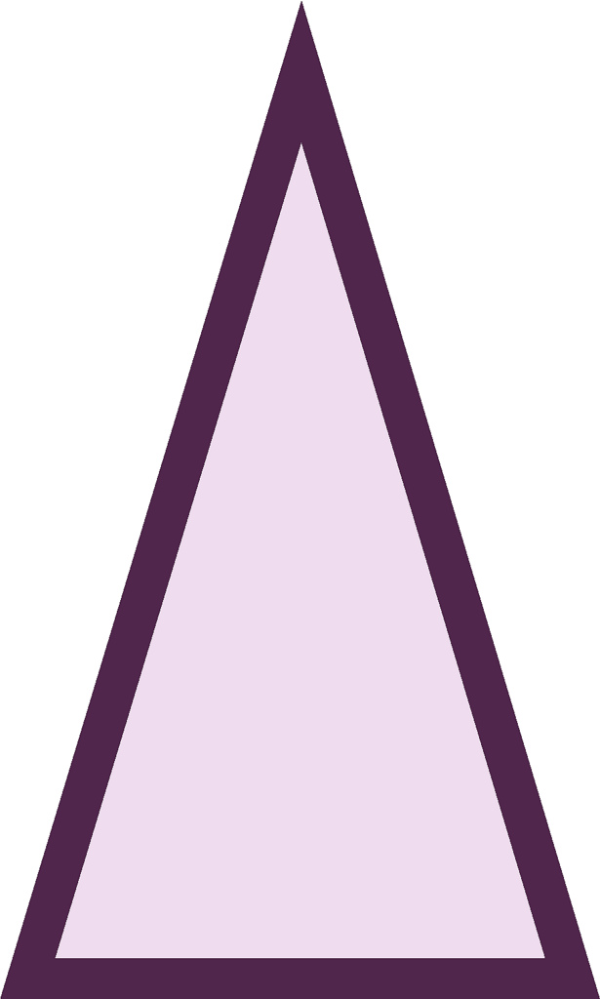** scalene equilateral isosceles

**Types of quadrilateral**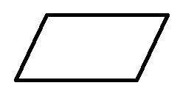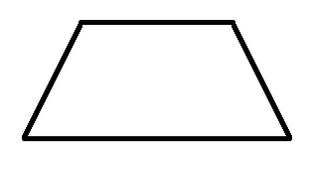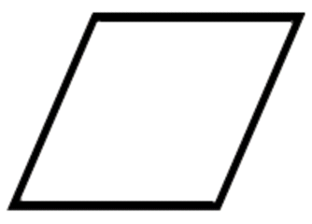parallelogram trapezium rhombus

**AREA**  
is the amount of space inside a 2D shape usually measured in cm2 or m2.  
**Area of a triangle**  
= (base x height) ÷ 2  
**Area of a parallelogram**= base x height  
*(Height = perpendicular height)*

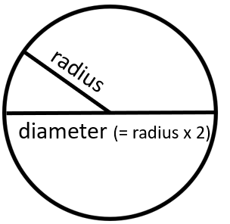

**Shape vocabulary  
perimeter** = measure around the edge (**circumference** = perimeter of a circle)

horizontal line parallel lines

vertical line perpendicular lines  
 (at right angles)



**The mean**The mean is a type of average. To find the mean, add up all the numbers and divide by how many there are. E.g. the mean of 4, 5, 3, 4 is 4. (Because 4 + 5 + 3 + 4 = 16, and 16 ÷ 4 = 4)

|  |  |  |  |
| --- | --- | --- | --- |
| **3D shapes** | square-based pyramid | triangular-based pyramid | triangular prism |
| **faces**  (the flat sides) | **5** | **4** | **5** |
| **edges** | **8** | **6** | **9** |
| **vertices**  (the points where the edges meet) | **5** | **4** | **6** |

**Volume** = the amount of space a 3D shape takes up, usually measured in cm3 or m3

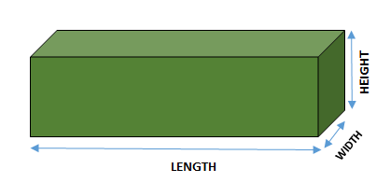

**Volume of a cuboid** = length x width x height

**Angles**

|  |  |
| --- | --- |
| full turn | 360° |
| half turn | 180° |
| right angle | 90° |
| acute angle | < 90° |
| obtuse angle | > 90° |
| reflex angle | >180° |
| angles on a straight line | 180° |
| angles inside a triangle | 180° |
| angles inside a quadrilateral | 360° |

**Fractions, decimals & percentages**

|  |  |  |  |
| --- | --- | --- | --- |
| 1/100 | 0.01 | 1% | ÷ 100 |
| 1/20 | 0.05 | 5% | ÷ 20 |
| 1/10 | 0.1 | 10% | ÷ 10 |
| 1/5 | 0.2 | 20% | ÷ 5 |
| ¼ | 0.25 | 25% | ÷ 4 |
| ½ | 0.5 | 50% | ÷ 2 |
| ¾ | 0.75 | 75% | ÷ 4, x3 |
| 1 | 1 | 100% | ÷ 1 |

**Measurement conversions**

|  |  |  |  |  |
| --- | --- | --- | --- | --- |
| **Month** | **Days** |  | 1 **cent**imetre | 10mm |
| January | 31 |  | 1 metre | 100cm |
| February | 28 (29 in leap year) |  | 1 **kilo**metre | 1,000 m |
| March | 31 |  |  |  |
| April | 30 |  | 1 mile | 1.6 km |
| May | 31 |  | 1 kilometre | 0.625 (5/8) mile |
| June | 30 |  |  |  |
| July | 31 |  | 1 **kilo**gram | 1,000 grams |
| August | 31 |  |  |  |
| September | 30 |  | 1 litre | 1,000 **milli**litres |
| October | 31 |  |  |  |
| November | 30 |  |  |  |
| December | 31 |  |  |  |
| 1 year = 365 days (≈ 52 weeks)  Leap year = 366 days | |  |  |  |
|  |  |

**Multiplication and division vocabulary**

|  |  |  |
| --- | --- | --- |
| **Term** | **Definition** | **Example** |
| factor | a number that divides exactly into another number | factors of 12 =  1, 2, 3, 4, 6, 12 |
| common factor | factors of two numbers that are the same | common factors of 8 and 12 = 1, 2, 4 |
| prime number | a number with only 2 factors: 1 and itself | 2, 3, 5, 7, 11, 13, 17, 19… |
| composite number | a number with more than two factors | 12  (it has 6 factors) |
| prime factor | a factor that is prime | prime factors of 12 =  2, 3 |
| multiple | a number in another number’s times table | multiples of 9 =  9, 18, 27, 36… |
| common multiple | multiples of two numbers that are the same | common multiples of 4 and 6 = 12, 24… |
| square numbers | the result when a number has been multiplied by itself | 25 (52 = 5x5) 49 (72 = 7x7) |
| cube numbers | the result when a number has been multiplied by itself 3 times | 8 (23 = 2x2x2)  27 (33 = 3x3x3) |