|  |
| --- |
| **History Knowledge Organiser – The Vikings** |

|  |
| --- |
|  |
|  |

|  |
| --- |
| **What knowledge and skills I will gain during this topic** |
| • develop a chronologically secure knowledge and understanding of British history  • understand how our knowledge of the past is constructed from a range of sources  • establish clear narratives within and across the periods  • develop the appropriate use of historical terms  • address historically valid questions about cause and significance  • construct informed responses that involve the thoughtful selection and organisation of relevant historical information  • note contrasts and connections over time. |

|  |  |
| --- | --- |
| **Key Vocabulary** | |
| **Danelaw** | The area in Britain that the Danish Vikings ruled over. |
| **Monastery** | A place where people who have dedicated their lives to religion, such as monks or nuns live. |
| **Pagan** | A person who believes in many gods |
| **Rune** | A letter from the alphabet used by the Vikings |
| **Longship** | A Viking ship used for fighting and carrying out raids. |
| **Conquer** | Get something by force |
| **Missionaries** | People sent to promote religions, especially Christianity |
| **Scandinavia** | The area made up of the countries: Denmark, Norway and Sweden |
| **Settlement** | A place where people have come to live |
| **Trader** | A person who sells goods |
| **Anglo-Saxons** | The main group of people living in Britain when the Vikings invaded. |

World map showing Great Britain and Scandinavia Map showing the Viking homelands and settlements

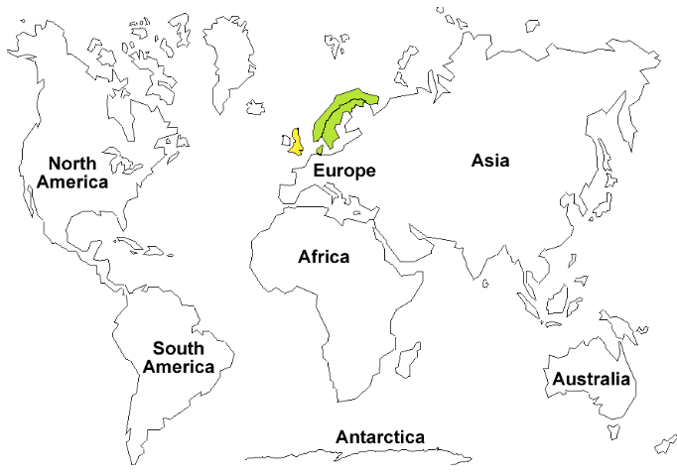 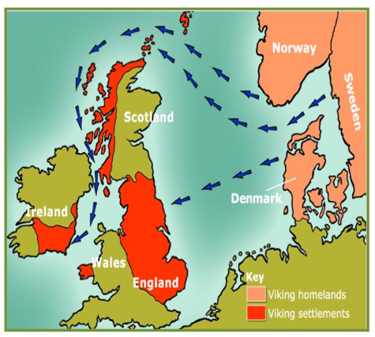

A Viking Longship

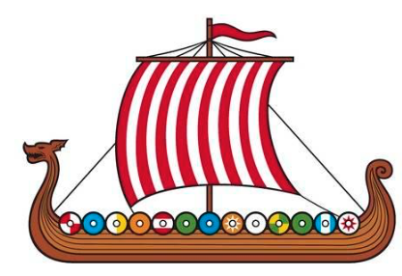

|  |
| --- |
| **Knowledge** |
| The Vikings (also known as Norsemen) came from three countries of Scandinavia: Denmark, Sweden and Norway. The name ‘Viking’ means a ‘pirate raid’. People who went off raiding in ships were said to be ‘going Viking’. Vikings sailed the seas, on longships (ships with sails and rowed with oars) raiding and taking over land.  One of the most detailed raids in history is that of the Lindisfarne monastery 8th June 793AD. |
|  |

The Scandinavian countries’ flags

