Year 3
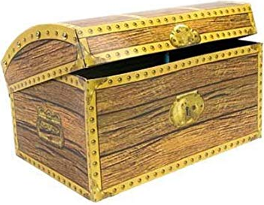
Treasure Chest Books
Book
Ratburger By David Walliams
George’s Marvellous Medicine By Roald Dahl
The Worst Witch By Jill Murphy
The 13-Story Treehouse By Andy Griffiths
The Boy Who Grew Dragons By Andy Shepherd
I Bet I Can Make You Laugh By Joshua Seigal
The Sheep-Pig By Dick King-Smith
Stig of the Dump By Clive King
Charlie and the Chocolate Factory By Roald Dahl
Mr Stink By David Walliams
Esio Trot By Roald Dahl
Bill’s New Frock By Anne Fine
Voices in the Park By Anthony Browne
The Animals of Farthing Wood By Colin Dann
The Hundred-Mile-An-Hour Dog By Jeremy Strong
The Lion and the Unicorn By Shirley Hughes
Scribbleboy By Philip Ridley
The Sandman and the Turtles By Michael Morpurgo
The Pebble in My Pocket By Meredith Hooper
Charlie & the Great Glass Elevator By Roald Dahl
Stink the Incredible Shrinking Kid By Megan McDonald
Horrible Histories- the Slimy Stuarts By Terry Deary
The Kingfisher Treasury of Ballet Stories By Caroline Plaisted & Patrice Aggs
The Enchanted Wood By Enid Blyton

