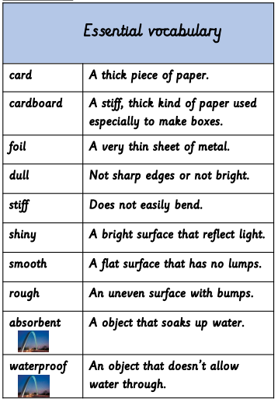

**Materials.**

**Properties of a material-** What a material is like and how it behaves.  
**Bend-** Bend an object by grabbing both ends of an   
object and bringing the ends inward together.

**Suitability-** The properties which are right for a specific   
purpose.

**Twist-** Twist an object y turning your hands in   
opposite directions.

**Squash-** Squash an object by pushing both hands   
together.

**Stretch-** Stretch an object by pulling your hands slowly  
and gently a part.

