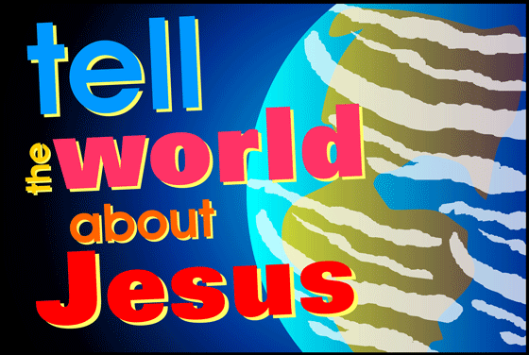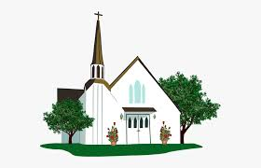

**KEY VOCABULARY**

**ecumenism cathedral diocese**

**Christian Unity Gentile inspired**

**SCRIPTURE**

Luke 4: 14-22

Isaiah 61: 1-2, 10-11

Luke 8: 1-3

John 17: 11-12, 20-23

I Corinthians 12: 12-17, 21, 27

**REFLECTION**

Lord, you fulfilled the hope of Simeon who did not die

until he had been privileged to

welcome the Messiah.

In Sacramental Celebrations we meet the Risen Christ.

May he continue to give us life.

Amen.

**OUR BIG QUESTION**

Do we all have a mission in life?

**MISSION**

Year 5 Topic 4

Ecumenism is the word used for promoting unity among Christian churches. One of the final prayers of Jesus was that all Christian families might be one.

The bishops continue the work of ‘the twelve’, the apostles, who continued the work and mission of Jesus.

The Church, the Christian family, is made up of smaller Christian families called dioceses. Each diocese is led by a bishop.