**Weekly:** complete the maths, SPAG and reading activities.

**Daily:** read and practice times tables.

**Arithmetic:**

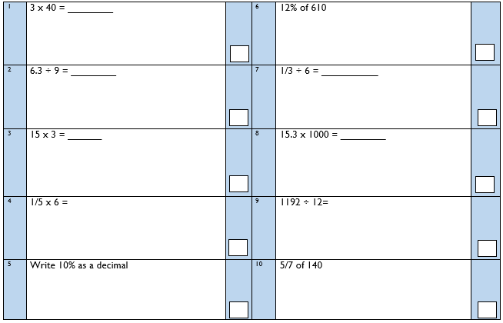

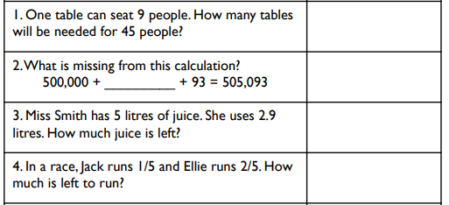**Fluency: Reasoning:**

One-minute challenge

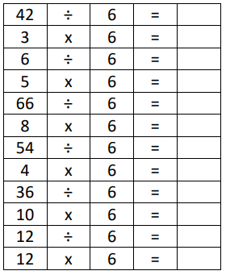



**Reading Comprehension:**

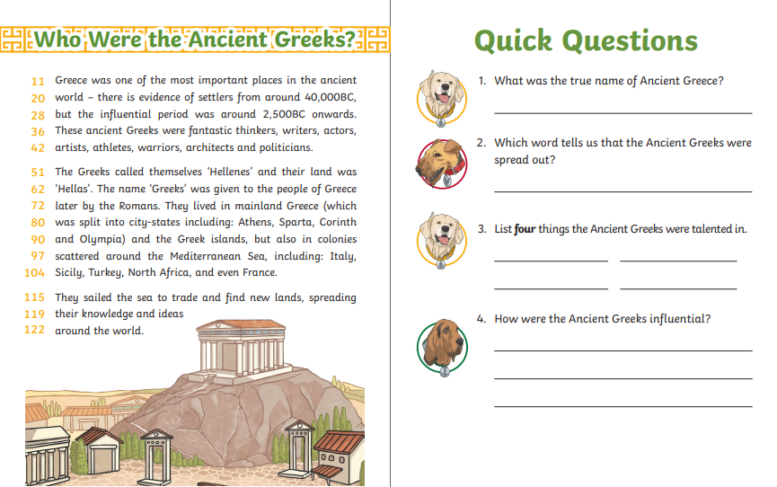

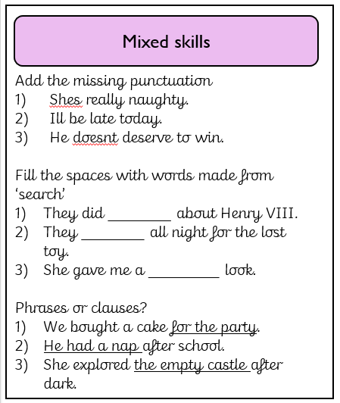**SPAG: Spellings to learn:**

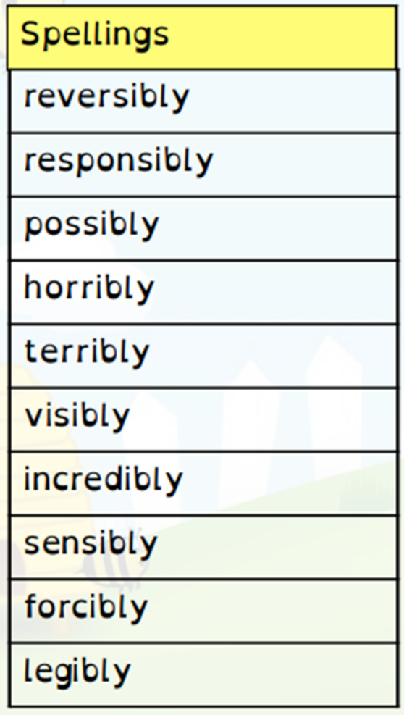

**Science:** Our next Science topic is the circulatory system. Do some research on the circulatory and write your notes below.

The circulatory system

**DT:** Our next DT topic is playground structures. Consider some of the playgrounds you have visited. Make a mind map below with the things that you think make a playground enjoyable. If possible, try to visit a park or a playground over half term!