**Weekly:** complete the maths, SPAG and reading activities to help revise for SATs.

**Daily:** read and practice times tables.

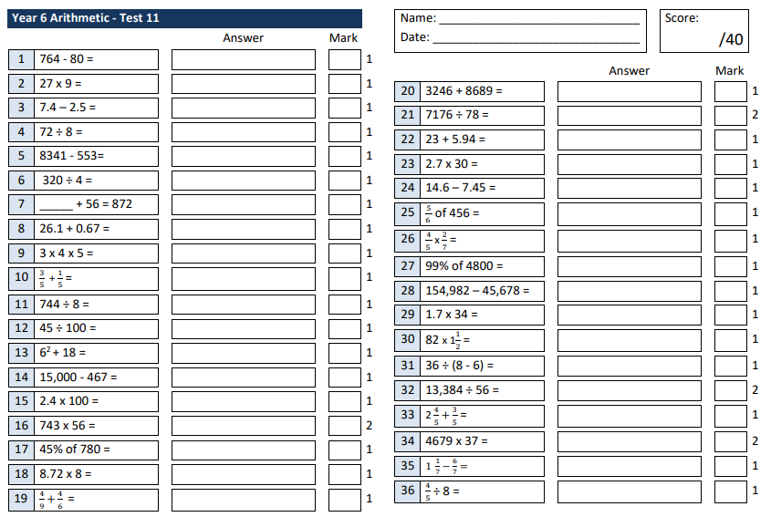**Arithmetic:**

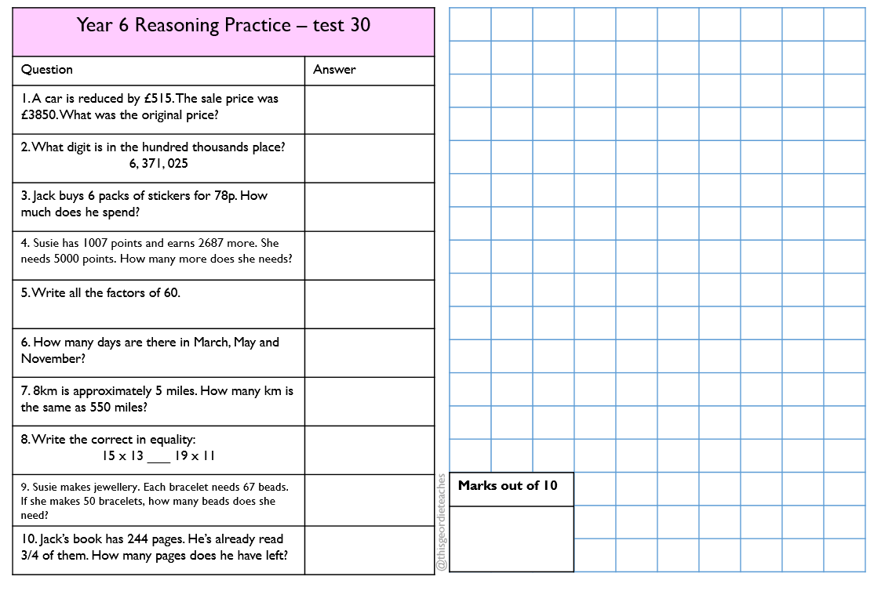**Reasoning:**

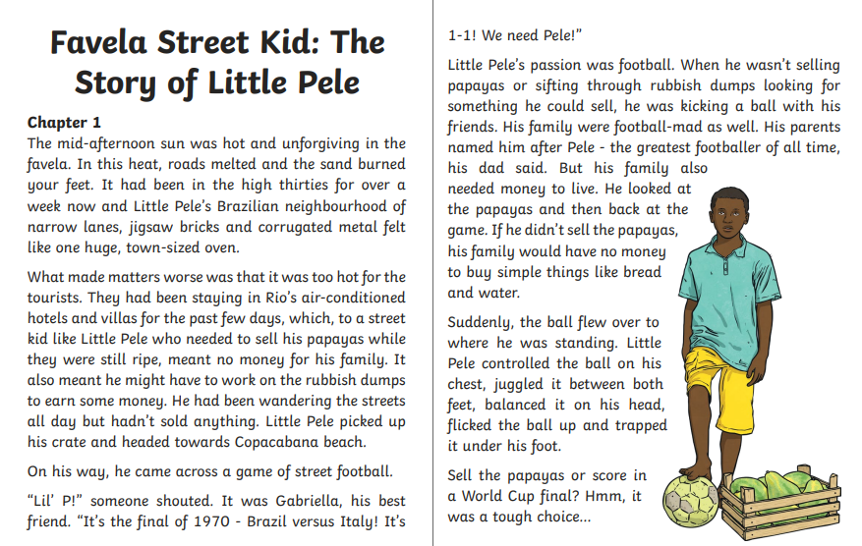**Reading Comprehension:**

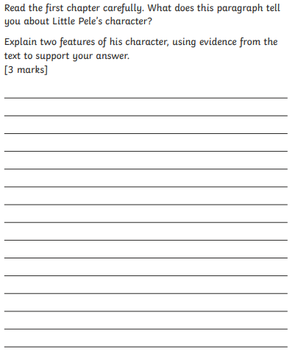

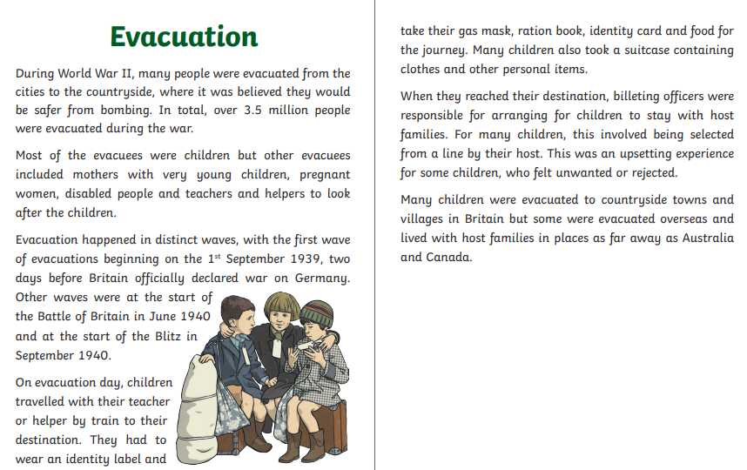

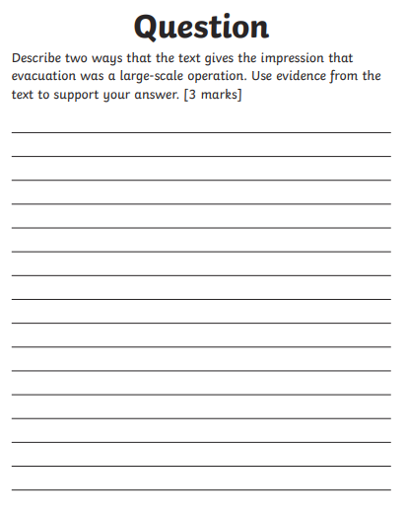

**SPAG:**

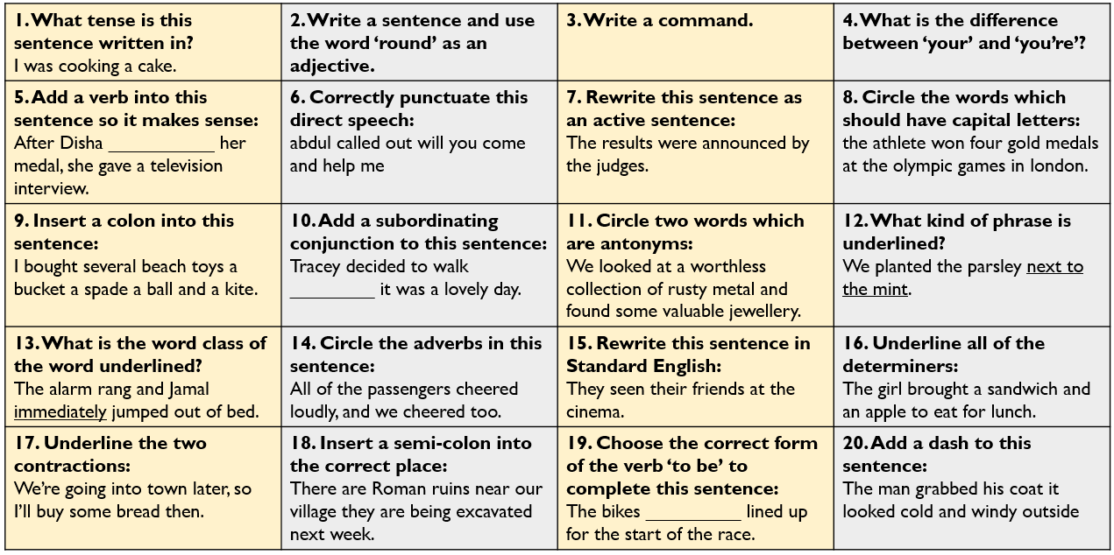

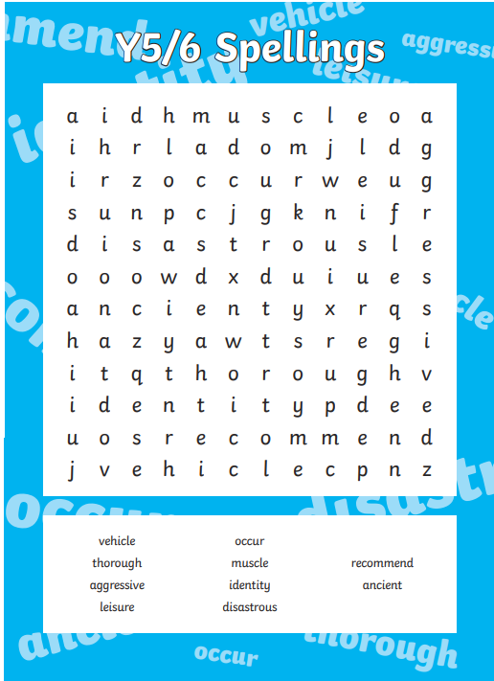**Spelling:**

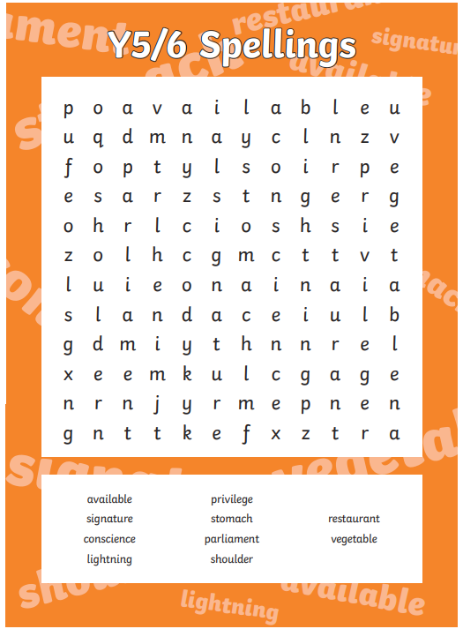

**Optional task:**

Research Paul Cezanne, a ‘Still Life’ artist. Can you create your own still life drawing or painting in his style?